Full House
Ultrasoft £14.95
(Review from QL World November 1986)
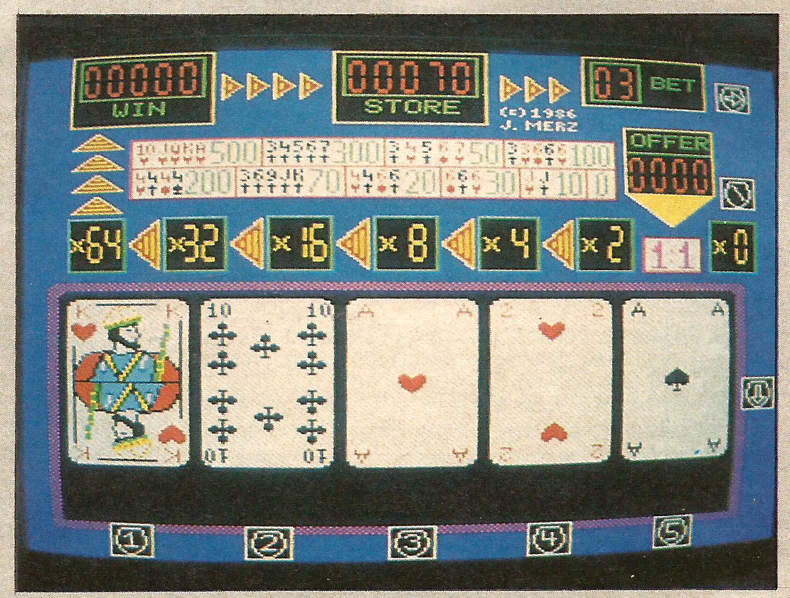
Full House. Or not, as in this case.
Card games and fruit machine simulations have been around for so long on virtually every machine you can think of that it difficult to summon enthusiasm when another is released.
Ultrasoft has managed to enliven the idea by combining the two. This kind of thing is apparently all the range in Germany, where the pups are full of card-toting machines urging the punters to part with their Deutschmarks and generally annoying everyone within ear-shattering chip-generated Musak.
The idea is simple. You start with 100 credits and must gambleon the outcome of a five-card poker hand. Initially the cards are displayed face down on the screen. First you transfer a few credits from the store into the pot by means of the cursor keys. Pressing the down cursor key causes all the cards to flip over and you can see what a poor hand you have.
There are five hold buttons, so you can retain any of the cards if it seems they might yield a promising result. The remaining cards are flipped again and you are either laughing all the way to the bank or heading for skid row.
If you are lucky enough to get a full house, a flush, a pair, or whatever, you have a second option to lose it all. By using the double button your winnings can be multiplied by a factor of up to 64 times – depending on how long your nerve holds. You could, of course, lose the lot but that is the gambling life for you.
There is not a great deal to Full House but it is good fun to play, worryingly addictive and will keep you amused for those odd half-hours when you have nothing better to do. The layout of the screen and graphics are extremely well implemented and the musak not in the least irritating.

