Use "Image Editor" program in Linux (wine).
Note:
Habi "Image Editor" program can work in linux using wine. Like the open/detect/close of IDE devices functionality don't work, you have to use other functionality. Habi "Image Editor" program can work with "raw" images.
Make a "raw" image from your IDE device.
- Insert your IDE device in your PC and make dmesg command. In this example, dmesg show that a 32MB card is /dev/sdd.
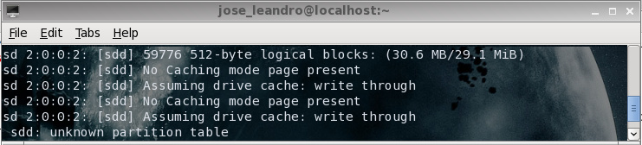
- Make a "raw" image using dd command. In many cases, you first need to make su or sudo command to have administrative privileges.
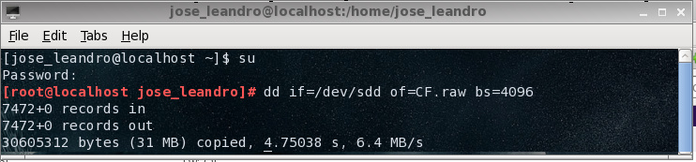
Open "raw" image with "Image Editor" program.
- Run Habi "Image Editor" program using wine.
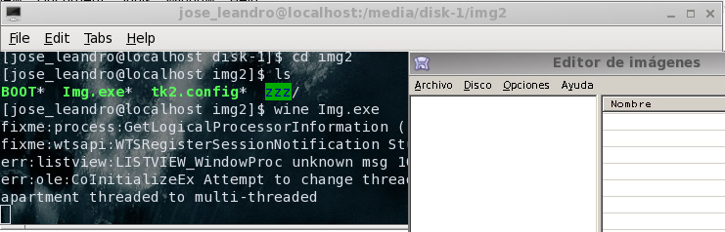
- Select "File" > "Open image" menu and look for the "raw" image you have been created. Select it and click in "open".
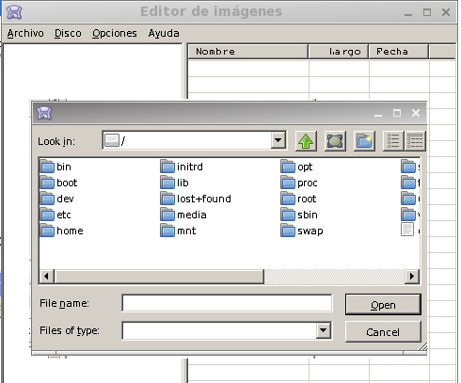
- The program will detect that "raw" image has QubIDE format. Click in "Ok" and the program will show the contents of the "raw" image.
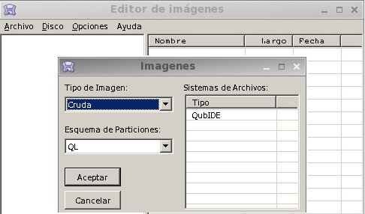
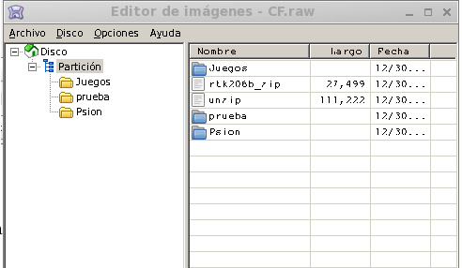
- The process of use zip or img files and Handle files for sinclair QL using "Image Editor" program is similar to windows PC.
Save "raw" image to your IDE device.
- Once you have finished, close "Image Editor" program. Take the "raw" image and use dd command to save the "raw" image to your IDE device.
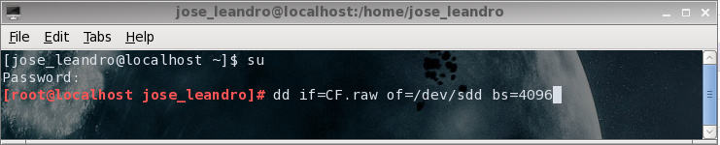
2015 Javier Herrera & José Leandro Novellón

