Handle files for sinclair QL using "Editor de imágenes" program.
Notes:
- Equiment use in this article: Sinclair QL with JS + TK rom(64K), QubIDE with 512K ram expansion, SD-IDE adpater and 32MB sd memory.
- PC with windows XP
Extract programs from QubIDE IDE unit.
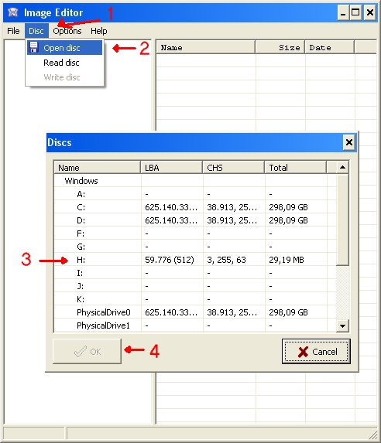
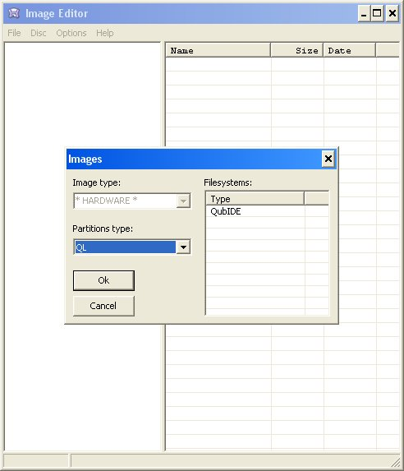
- 1 Open "Image Editor" program and select "Disc" > "Open disc" menu.
- 2 Select your QL IDE unit and press "OK".
- 3 The program will detect that your IDE unit has QubIDE format.
- 4 Now is time to indicate "Image Editor" program that you want to export programs. Like QL header are needed, we'll select "Options" > "Headers" > "QL".
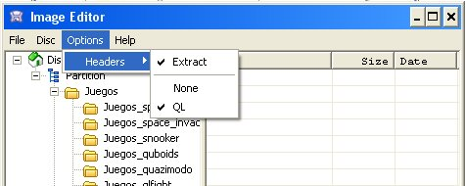
- Drag the programs from "Image Editor" to PC. In windows 7 / 8 maybe it doesn't work. In this case use "File" -> "Extract files" menu.
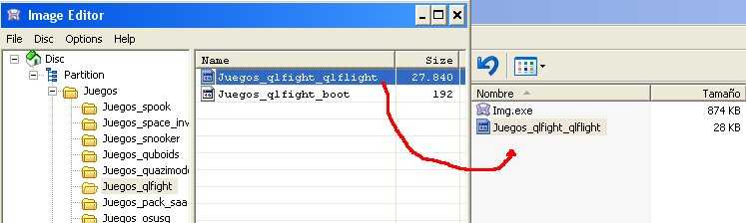
Import programs from QubIDE IDE unit.
- 1 Open "Image Editor" program and select "Disc" > "Open disc" menu.
- 2 Select your QL IDE unit and press "OK".
- 3 The program will detect that your IDE unit has QubIDE format.
- 4 Indicate "Image Editor" that it makes nothing with QL Headers. "Options" > "Headers" > "None" menu.
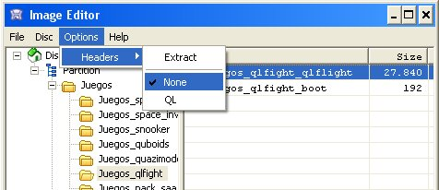
- Drag the programs from PC to "Image Editor". In windows 7 / 8 maybe it doesn't work. In this case use "File" -> "Insert files" menu.
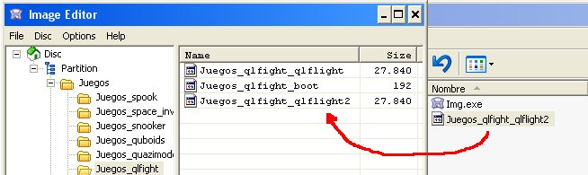
Make directory.
- Click in "partition" (Left window) and then click in the right window with right mouse button.Choose "Create directory" and write the name of the directory you want.
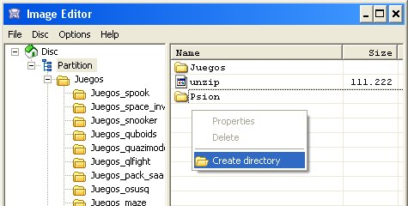
Delete programs.
- Click in the program you want to delete. Click right mouse button and choose "Delete".
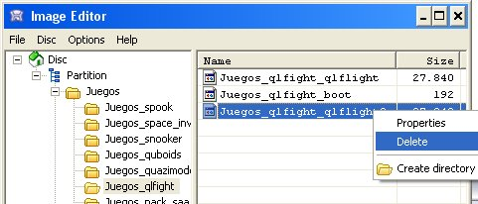
2015 José Leandro Novellón

