Graphics Toolkit

TALENT has been setting the standard of QL software for more than a year. Its major successes include GraphiQL, Cartridge Doctor, Zkul and West. In the sumer of 1985 the company’s talented programming team was set the task of producing a professional quality utility for the Sinclair User Annual.
The Talent Graphics Toolkit is the resultof two months hard work. You can useit to experiment with the new science of Fractals, which deals with the replication of natural shapes to form landscapes, rock formations and even buildings. The techniques a re similar to those used by Walt Disney Productions to create Tron. Enter a new world of computer generated graphics and a new area of programming.
Fractals were defined by Mandelbrot who conceived and developed ‘a new geometry of nature’. Natural shapes, such as clouds, mountains, trees, coastlines, exhibit a totally different levelof complexity to that of standard geometric shapes. Fractals describe many of the fragmented and irregular patterns foundin nature and the degree of that irregularity is identical at all levels. For example, a coastline can be represented on a large-scale map as a series of bays and inlets. A more detailed map will reveal that the bays are themselves broken up into smaller bays and indentations.
A simple example of a fractal shape is the snowflake shown in figure 1. The basic frame is an equilateral triangle (A). The next shape (B) has been formed by adding equilateral triangles, one third of the size of the original, on the central third of each side. The same process is repeated in in (C) and can be repeated ad infinitum until the detailis too fine to see.
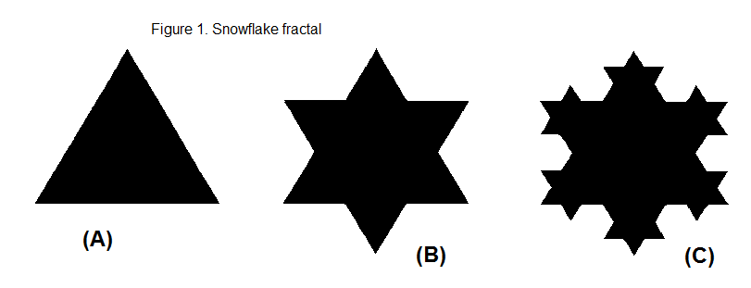
TALENT’s fractal program allows you to choose one of twenty stored frame shapes or to define your own. The segment, or method by which each line is to be modified, can also be selected from a library of twenty stored shapes or can be user-defined. Finally, the computer draws the frame on screen at any levelor geneartion of complexity you choose.

Program Design

The program has been carefully engineered. The interface should allow you to obtain pleasing results quickly and easily. You should not need to undertsand the basic mathematical concepts. All help is provided on-screen and no manual is necessary.
Main Menu – nearly always on screen. Options are highlighted in turn by using the cursor keys and selected with Space. When an option is chosen, a drop-down sub-menu is displayed.
Sub-Menu – brought down when an optionis chosen. Options are selected in turn with the Space key. All sub-menus have an ESCape option which returns you to the main menu.
Segment Window – always on screen. This window displays the current segment selected out of a library of 20. The first 10 of those are defined. The remainder are stored as straight lines which can be picked up and edited to become any shape you wish.
Frame Window – the same as segment window. Displays the current frame selected from the frame library. The first 10 are defined, the remainder can be edited in the same way as segments.
Input/Error/Message Window – this window is used when input is required – filenames, It will also display errors and other messages.

Summary Of Functions

After Segments/Frames
On-screen edit – used to change the segment or frame on-screen. After the segment/frame is drawn, you move the cursor to a point on the line. Then pick up the point and pull it to a new position using the cursor keys. The space bar is used ot register the changed. That is useful for specifying irregular shapes.
Numerical data – you are asked to input a series of numbers - distance, angle - to specify the segment or frame. That is useful for specifying regular shapes. Distance is scaled proportionately, for example, a standard length for the frame is 50 and for the segment, 10. The angles start at 0 degrees and work clockwise – 90 degrees, 180 degrees, 270 degrees and back to 0 degrees.
Change Segment/Frame
The current segment or frame is changed to another in store – 1-20.
Draw Fractal
When this item is specified on the main menu, the sub-menu will ask for various data which you must enter as numbers on the keyboard. The options are mode, paper, ink, x co-ordinate, y co-ordinate, depth and scale.
Permanent Store
Format device will format a specified device.
Directory device will give a directory of the specified device.
Save fractals will save the present store arrays.
Load fractals will load the store arrays.

Additional information

Occasionally values – paper, ink – must be entered in the input window. The default value – printed in brackets after the option – is printed first. If that is to be changed, it must first be erased using the Sincalir erase sequence of CTRL and back arrow. Then the new value must be typed in, followed by ENTER.
An error message will be generated if a segment is ‘closed’ – the start and end point are put in the same place. If the start and end point ofa segment are too close together, the segment will not fit into the window. It will also run off the main fractal drawing screen. It should be changed using the on-screen edit to make it fit.

